6个纯代码题，2个简答

简答是json对比xml的优缺点

Pros: Readability and extensibility. With a simple syntax on the one hand and a canonical label form on the other, it is difficult to distinguish between victory and defeat.

If you know the JSON structure in advance, it is wonderful to use JSON for data transfer, and you can write very practical, beautiful and readable code.

All have rich coding tools

Cons: XML is hard to decode, while JSON is easy.

- XML file format is complex and the file size is huge.

- The format of JSON data is relatively simple, and the file size is relatively small.

还有个DOM的功能作用

The Document Object Model (DOM) is a standard programming interface recommended by the W3C organization for handling extensible markup languages. It is a platform- and language-independent application program interface (API) that dynamically accesses programs and scripts, updating their content, structure, and the style of the www document (HTMl and XML documents are defined by the description section).

DOM

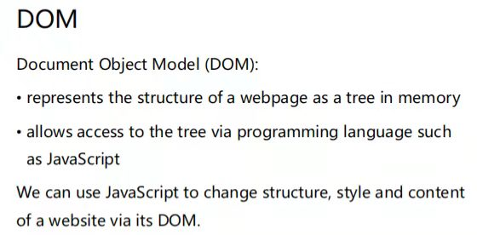

DOM

文档对象模型)

将网页的结构表示为内存中的树允许通过程序设计语言(如JavaScript)访问树

我们可以使用JavaScript通过DOM改变网站的结构、风格和内容

Document Object Model(DOM):

represents the structure of a web page as a tree in memory allows access to the tree via programming language such as JavaScript

We can use JavaScript to change structure, style and content of a website via its DOM

代码有个写json和ajax功能函数的

还有个写xml和dtd的

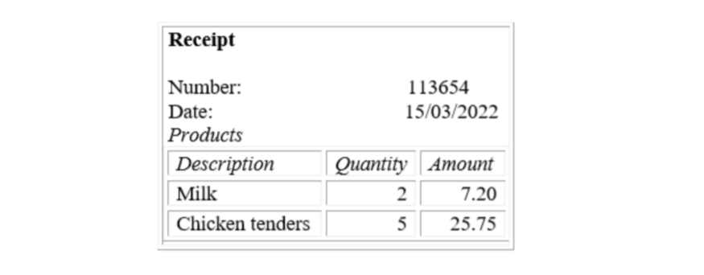

|  |  |
| --- | --- |
|  | <?xml version="1.0" encoding="utf-8" standalone="yes" ?> |
|  | <!DOCTYPE receipt [ |
|  | <!ELEMENT receipt (product\*)> |
|  | <!ATTLIST receipt number CDATA #REQUIRED> |
|  | <!ATTLIST receipt date CDATA #REQUIRED> |
|  | <!ATTLIST receipt studentName CDATA #REQUIRED> |
|  | <!ATTLIST receipt studentNumber CDATA #REQUIRED> |
|  | <!ELEMENT product (description, quantity, amount)> |
|  | <!ELEMENT description (#PCDATA)> |
|  | <!ELEMENT quantity (#PCDATA)> |
|  | <!ELEMENT amount (#PCDATA)> |
|  | ]> |
|  |  |
|  | <receipt number="113654" date="15/03/2022" studentName="Feng Xiong" studentNumber="7353388"> |
|  | <product> |
|  | <description>Milk</description> |
|  | <quantity>2</quantity> |
|  | <amount>7.20</amount> |
|  | </product> |
|  | <product> |
|  | <description>Chicken tenders</description> |
|  | <quantity>5</quantity> |
|  | <amount>25.75</amount> |
|  | </product> |
|  | </receipt> |

再就是写form的

还有两个写表格和css的

有一个写计时器的

还有一个基本的写个输入框获取数字，算一算的那种

主要考CSS

ajax那个只写核心的json处理就行，其他都是完整的

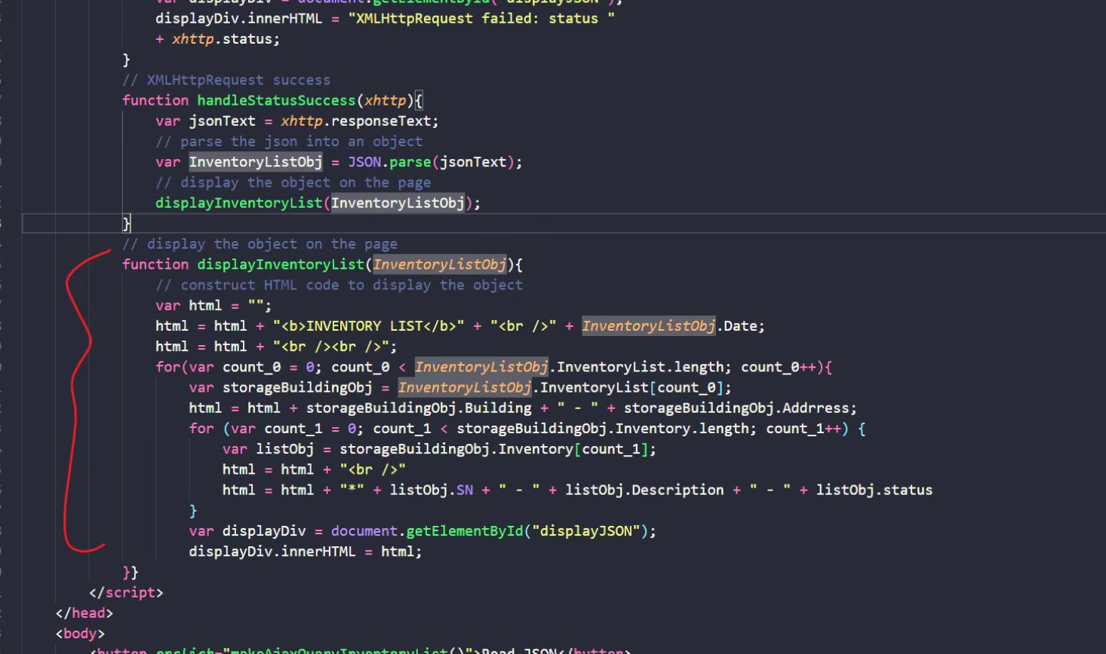

一个js动画 一个form 一个xml+dtd 一个json+ajax的display函数 一个assignment1的题 一个是assignment2的题

一个dom 一个json比xml的优点和缺点

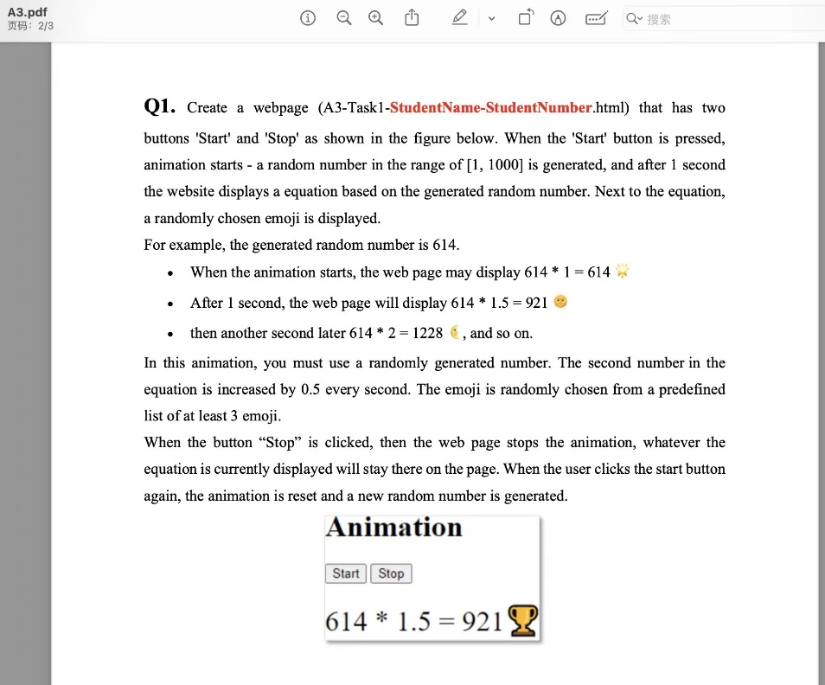

|  |
| --- |
| <!DOCTYPE html> |
|  | <html lang="en"> |
|  | <head> |
|  | <meta charset="UTF-8"> |
|  | <title>FengXiong - 7353388</title> |
|  |  |
|  | <script> |
|  | var interval = null; // timer |
|  | var emojis = [' |
|  | var num1 = 0; |
|  | var num2 = 1; |
|  |  |
|  | // Start the animation process |
|  | function startAnimation() { |
|  | // initial the display field |
|  | initialContent(); |
|  |  |
|  | // start iteratively update the display field |
|  | if (null == interval) { |
|  | interval = setInterval(updateContent, 1000); |
|  | } |
|  | } |
|  |  |
|  | // Initial the displayDiv |
|  | function initialContent() { |
|  | // generate the random number in range [1, 1000] |
|  | num1 = Math.floor(Math.random() \* 1000) + 1; |
|  | num2 = 1; |
|  |  |
|  | document.getElementById("displayDiv").style.display = "block"; |
|  | document.getElementById("first\_num").innerHTML = num1; |
|  | document.getElementById("second\_num").innerHTML = num2; |
|  | document.getElementById("result").innerHTML = num1 \* num2; |
|  | document.getElementById("emoji").innerHTML = emojis[Math.floor(Math.random() \* 6)]; |
|  | } |
|  |  |
|  | // Update the displayDiv per second |
|  | function updateContent() { |
|  | num2 += 0.5; |
|  |  |
|  | // update the second number |
|  | var second\_num\_span = document.getElementById("second\_num"); |
|  | second\_num\_span.innerHTML = num2; |
|  |  |
|  | // update the calculation result |
|  | var result\_span = document.getElementById("result"); |
|  | result\_span.innerHTML = num1 \* num2; |
|  |  |
|  | // update the emoji |
|  | var emoji\_span = document.getElementById("emoji"); |
|  | emoji\_span.innerHTML = emojis[Math.floor(Math.random() \* 3)]; |
|  | } |
|  |  |
|  | // Stop the animation process |
|  | function stopAnimation() { |
|  | clearInterval(interval); |
|  | interval = null; |
|  | } |
|  | </script> |
|  | </head> |
|  |  |
|  | <body> |
|  | <h1>Animation</h1> |
|  |  |
|  | <!--Start button & Stop button--> |
|  | <button onclick="startAnimation()">Start</button> |
|  | <button onclick="stopAnimation()">Stop</button> |
|  | <br> <br> |
|  |  |
|  | <!--Display field--> |
|  | <div style="display: none" id="displayDiv"> |
|  | <span id="first\_num"></span> \* |
|  | <span id="second\_num"></span> = |
|  | <span id="result"></span> |
|  | <span id="emoji"></span> |
|  | </div> |
|  |  |
|  | </body> |
|  | </html> |

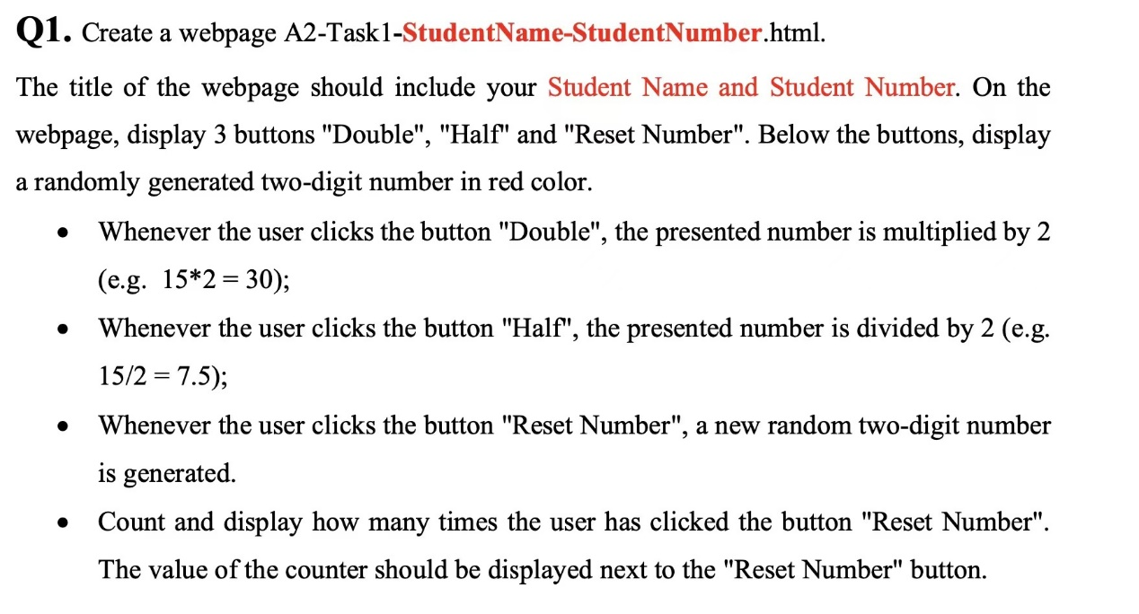

|  |  |
| --- | --- |
|  | <!DOCTYPE html> |
|  | <html lang="en" xmlns="http://www.w3.org/1999/html"> |
|  | <head> |
|  | <meta charset="UTF-8"> |
|  | <title>HeHouCen 2021124092</title> |
|  | </head> |
|  | <style> |
|  |  |
|  | </style> |
|  | <body> |
|  | <p>Number:</p><span id="span" style="color:red">24</span></br> |
|  | <button onclick="Double()">Double</button> |
|  | <button onclick="Half()">Half</button></br> |
|  | The number of click:<button onclick="show()">Reset Number</button><span style="color: lightsalmon" id="span2">0</span> |
|  |  |
|  | </body> |
|  | <script> |
|  | function Double(){ |
|  | var Number1=document.getElementById("span") |
|  | Number1.innerHTML=Number1.innerHTML\*2; |
|  |  |
|  | } |
|  | function Half(){ |
|  | var Number2=document.getElementById("span") |
|  | Number2.innerHTML=Number2.innerHTML/2; |
|  |  |
|  | } |
|  | var count=0 |
|  | function show(){ |
|  | count=count++; |
|  | var number=Math.floor(Math.random()\*90) + 10; |
|  | document.getElementsByTagName('span')[0].innerHTML = number; |
|  | document.getElementById("span2").innerHTML++; |
|  |  |
|  | } |
|  | </script> |
|  | </html> |

<a href="http://didd.gov" target="\_blank">Kingdom of Didd</a>

HTML CSS

<br/><br/>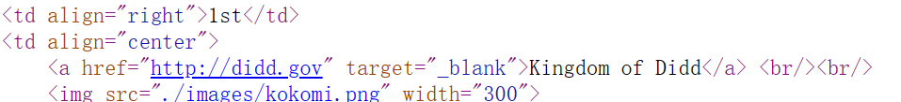

|  |  |
| --- | --- |
|  | <!DOCTYPE html> |
|  | <html lang="en"> |
|  | <head> |
|  | <meta charset="UTF-8"> |
|  | <title>Programming Exercise</title> |
|  | </head> |
|  |  |
|  | <body> |
|  | <h1>Feng Xiong, SN: 7353388</h1> |
|  | <p style="font-size: 50px; |
|  | background-color: #ff000010; |
|  | padding: 30px; |
|  | text-align: center; border: 5px dotted red;"> |
|  | <span style="color: orange;">World</span> |
|  | <span style="color: pink;">Gurning</span> |
|  | <span style="color: blue;">Competition</span> |
|  | &#x1F61D; |
|  | </p> |
|  |  |
|  | <!--<table style="border-style: dotted; |
|  | border-collapse: separate; |
|  | border-spacing: 10px;">--> |
|  | <table style="border-style: none; |
|  | border-collapse: collapse;"> |
|  | <!--表头--> |
|  | <thead> |
|  | <tr style="font-size: 40px; |
|  | color: navy; |
|  | background-color: #ff000010; |
|  | padding: 20px;"> |
|  | <th style="text-align: right; |
|  | vertical-align: top; |
|  | border: 5px dashed black;"> |
|  | Ranking |
|  | </th> |
|  | <th style="text-align: center; |
|  | vertical-align: top; |
|  | border: 5px dashed black;"> |
|  | Team |
|  | </th> |
|  | <th style="text-align: left; |
|  | vertical-align: top; |
|  | border: 5px dashed black;"> |
|  | Member |
|  | </th> |
|  | </tr> |
|  | </thead> |
|  |  |
|  | <!--主体--> |
|  | <tbody> |
|  | <!--First row--> |
|  | <tr style="background-color: #cc007711;"> |
|  | <td style="font-size: 60px; |
|  | color: maroon; |
|  | text-align: right; |
|  | vertical-align: top; |
|  | border: 1px solid gray; |
|  | padding: 20px;"> |
|  | 1st |
|  | </td> |
|  | <td style="text-align: center; |
|  | vertical-align: top; |
|  | border: 1px solid gray; |
|  | padding: 20px;"> |
|  | <a href="[http://didd.gov](http://didd.gov" \t "C:/document/%E7%AC%AC%E4%B8%89%E5%AD%A6%E6%9C%9F-PPT-20221219/884%20Web%20Development/Web%20Development/Exercise%203/_blank)" target="\_blank">Kingdom of Didd</a> <br/><br/> |
|  | <img src="[./images/kokomi.png](C:/document/%E7%AC%AC%E4%B8%89%E5%AD%A6%E6%9C%9F-PPT-20221219/884%20Web%20Development/Web%20Development/Exercise%203/./images/kokomi.png" \t "C:/document/%E7%AC%AC%E4%B8%89%E5%AD%A6%E6%9C%9F-PPT-20221219/884%20Web%20Development/Web%20Development/Exercise%203/_blank)" width="300"> |
|  | </td> |
|  | <td style="text-align: left; |
|  | vertical-align: top; |
|  | border: 1px solid gray; |
|  | padding: 20px;"> |
|  | <ul style="color: green;"> |
|  | <li style="color: purple; padding: 10px;"><strong>Thing 1</strong> <em>(team leader)</em></li> |
|  | <li style="padding: 10px;">North-Going Zax</li> |
|  | <li style="padding: 10px;">Cindy-Lou Who</li> |
|  | <li style="padding: 10px;">McMonkey McBean</li> |
|  | <li style="padding: 10px;">Vlad Vlad-i-Koff</li> |
|  | </ul> |
|  | </td> |
|  | </tr> |
|  |  |
|  | <!--Second row--> |
|  | <tr style="background-color: #55ff7720;"> |
|  | <td style="font-size: 60px; |
|  | color: maroon; |
|  | text-align: right; |
|  | vertical-align: top; |
|  | border: 1px solid gray; |
|  | padding: 20px;"> |
|  | 2nd |
|  | </td> |
|  | <td style="text-align: center; |
|  | vertical-align: top; |
|  | border: 1px solid gray; |
|  | padding: 20px;"> |
|  | <a href="[http://binn.gov](http://binn.gov" \t "C:/document/%E7%AC%AC%E4%B8%89%E5%AD%A6%E6%9C%9F-PPT-20221219/884%20Web%20Development/Web%20Development/Exercise%203/_blank)" target="\_blank">Kingdom of Binn</a> <br/><br/> |
|  | <img src="[./images/Scaramouche.png](C:/document/%E7%AC%AC%E4%B8%89%E5%AD%A6%E6%9C%9F-PPT-20221219/884%20Web%20Development/Web%20Development/Exercise%203/./images/Scaramouche.png" \t "C:/document/%E7%AC%AC%E4%B8%89%E5%AD%A6%E6%9C%9F-PPT-20221219/884%20Web%20Development/Web%20Development/Exercise%203/_blank)" width="300"> |
|  | </td> |
|  | <td style="text-align: left; |
|  | vertical-align: top; |
|  | border: 1px solid gray; |
|  | padding: 20px;"> |
|  | <ul style="color: green; padding: 10px;"> |
|  | <li style="color: purple; padding: 10px;"><strong>Thing 2</strong> <em>(team leader)</em></li> |
|  | <li style="padding: 10px;">South-Going Zax</li> |
|  | <li style="padding: 10px;">The Grinch</li> |
|  | <li style="padding: 10px;">Bartholomew Cubbins</li> |
|  | <li style="padding: 10px;">Fizza-ma Wizza-ma Dill</li> |
|  | </ul> |
|  | </td> |
|  | </tr> |
|  | </tbody> |
|  | </table> |
|  | </body> |
|  | </html> |
|  |  |
|  |  |

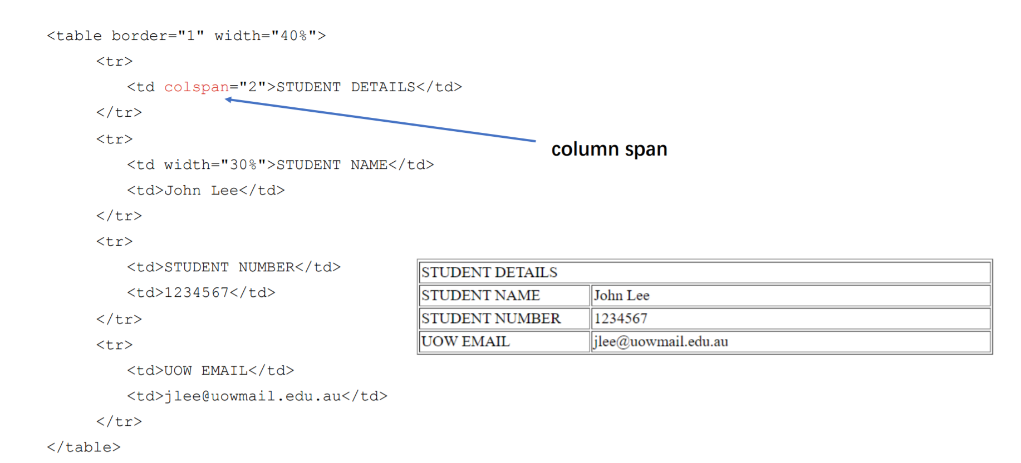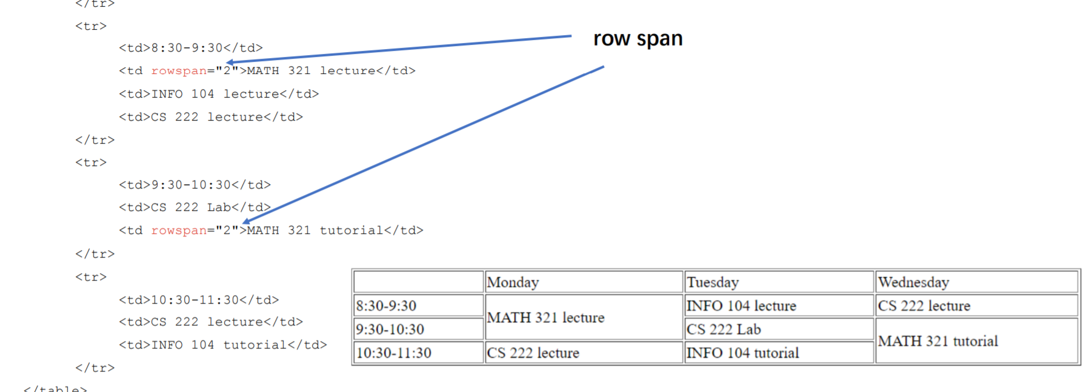

FORM

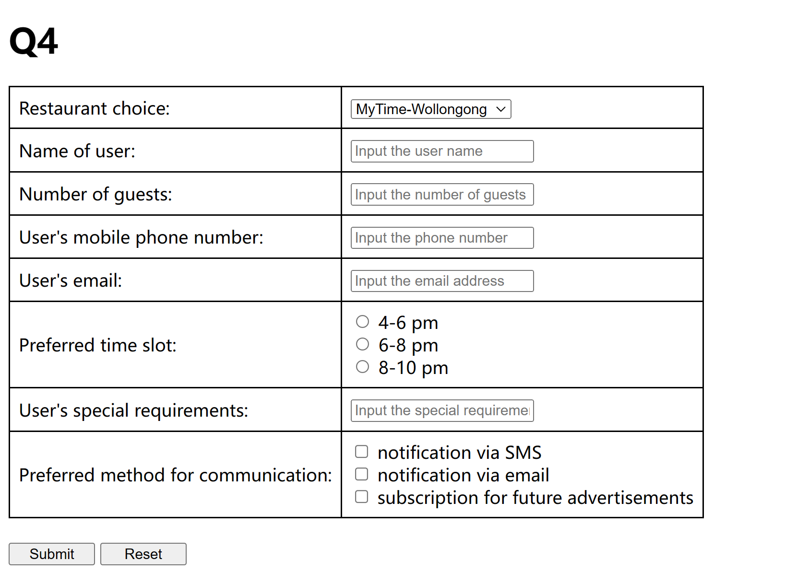

|  |  |
| --- | --- |
|  | <!DOCTYPE html> |
|  | <html lang="en"> |
|  | <head> |
|  | <meta charset="UTF-8"> |
|  | <style> |
|  | table, td { |
|  | border-collapse: collapse; |
|  | border: solid; |
|  | padding: 8px; |
|  | } |
|  | </style> |
|  |  |
|  |  |
|  | <title>FengXiong - 7353388</title> |
|  | </head> |
|  |  |
|  | <body> |
|  | <h1>Q4</h1> |
|  |  |
|  | <!--table of web form--> |
|  | <form action="http://mychoice55.com/query" method="get"> |
|  | <table> |
|  | <!--drop-down list for the restaurant choice--> |
|  | <tr> |
|  | <td> |
|  | Restaurant choice: |
|  | </td> |
|  | <td> |
|  | <select name="rest"> |
|  | <option value="1">MyTime-Wollongong</option> |
|  | <option value="2">PerfectDish-Kiama</option> |
|  | <option value="3">DinerOut-Buli</option> |
|  | <option value="4">SpotOn-Shellharbour</option> |
|  | </select> |
|  | </td> |
|  | </tr> |
|  |  |
|  | <!--text field for the name of the user--> |
|  | <tr> |
|  | <td> |
|  | Name of user: |
|  | </td> |
|  | <td> |
|  | <input type="text" name="name" placeholder="Input the user name"> |
|  | </td> |
|  | </tr> |
|  |  |
|  | <!--text field for the number of guests--> |
|  | <tr> |
|  | <td> |
|  | Number of guests: |
|  | </td> |
|  | <td> |
|  | <input type="text" name="num" placeholder="Input the number of guests"> |
|  | </td> |
|  | </tr> |
|  |  |
|  | <!--text field for the user's phone number--> |
|  | <tr> |
|  | <td> |
|  | User's mobile phone number: |
|  | </td> |
|  | <td> |
|  | <input type="text" name="phone" placeholder="Input the phone number"> |
|  | </td> |
|  | </tr> |
|  |  |
|  | <!--text field for the user's email--> |
|  | <tr> |
|  | <td> |
|  | User's email: |
|  | </td> |
|  | <td> |
|  | <input type="text" name="email" placeholder="Input the email address"> |
|  | </td> |
|  | </tr> |
|  |  |
|  | <!--3 radio buttons for the preferred time slot--> |
|  | <tr> |
|  | <td> |
|  | Preferred time slot: |
|  | </td> |
|  | <td> |
|  | <input type="radio" name="time" value="e"> 4-6 pm <br> |
|  | <input type="radio" name="time" value="m"> 6-8 pm <br> |
|  | <input type="radio" name="time" value="l"> 8-10 pm <br> |
|  | </td> |
|  | </tr> |
|  |  |
|  | <!--text field for the user's special requirements--> |
|  | <tr> |
|  | <td> |
|  | User's special requirements: |
|  | </td> |
|  | <td> |
|  | <input type="text" name="req" placeholder="Input the special requirements"> |
|  | </td> |
|  | </tr> |
|  |  |
|  | <!--3 checkboxes for the preferred method for communication--> |
|  | <tr> |
|  | <td> |
|  | Preferred method for communication: |
|  | </td> |
|  | <td> |
|  | <input type="checkbox" name="note" value="SMS"> notification via SMS <br> |
|  | <input type="checkbox" name="note" value="EM"> notification via email <br> |
|  | <input type="checkbox" name="note" value="SUB"> subscription for future advertisements <br> |
|  | </td> |
|  | </tr> |
|  | </table> |
|  |  |
|  | <br> |
|  | <!--2 buttons for submit and reset form--> |
|  | <input type="submit" value="Submit" style="width: 80px"> |
|  | <input type="reset" value="Reset" style="width: 80px"> |
|  | </form> |
|  |  |
|  |  |
|  |  |
|  | </body> |
|  | </html> |

